PIZZA SALES SQL QUERIES
KPI’S:
Total_revenue:
select sum(total_price) as Total_Revenue
from pizza_sales

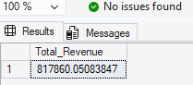

Average order value:
select (sum(total_price)/count(distinct order_id)) as Avg_order_value
from pizza_sales

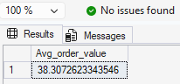
Total pizza solds:
select sum(quantity) as total_pizza_sold from pizza_sales

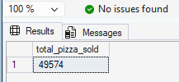
Total_orders:
select count(order_id) as Total_orders from pizza_sales
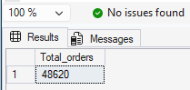
Average pizza per order
select cast(cast(sum(quantity) AS DECIMAL(10,2))/
cast(count(distinct order_id) AS DECIMAL(10,2))as DECIMAL(10,2)) AS Avg_pizza_per_order from pizza_sales
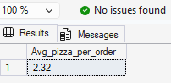
select datename(dw,order_date) as order_day, count(distinct order_id) as Total_orders
from pizza_sales
group by datename(dw,order_date)
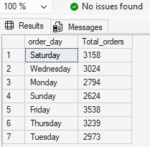

select datename(month,order_date) as Month_name, count(distinct order_id)
from pizza_sales
group by datename(month,order_date)

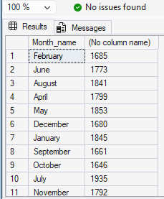
select pizza_category, sum(total_price) * 100 / (select sum(total_price) from pizza_sales) as percentage_Total_Sales from pizza_sales group by pizza_category
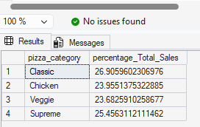

select pizza_category,sum(total_price) as Total_sales, sum(total_price) * 100 / (select sum(total_price) from pizza_sales
where month(order_date)=1) as percentage_Total_Sales
from pizza_sales
where month(order_date)=1
group by pizza_category

select pizza_size,sum(total_price) as Total_sales, sum(total_price) * 100 / (select sum(total_price) from pizza_sales) as percentage_Total_Sales
from pizza_sales
group by pizza_size

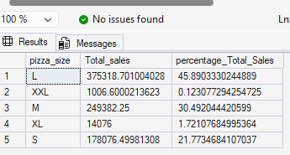

SELECT pizza_size,
CAST(SUM(total_price) AS DECIMAL(10,2)) AS Total_sales,
CAST(
SUM(total_price) * 100.0 /
(SELECT SUM(total_price) FROM pizza_sales)
AS DECIMAL(10,2)
) AS percentage_Total_Sales
FROM pizza_sales
GROUP BY pizza_size
ORDER BY percentage_Total_Sales DESC;
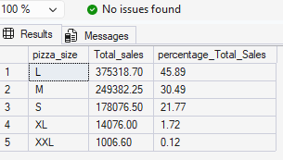

select top 5 pizza_name, sum(total_price) As Total_Revenue from pizza_sales
group by pizza_name
order by Total_Revenue desc
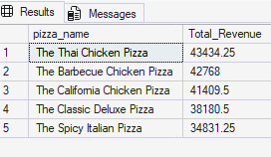

select top 5 pizza_name, sum(total_price) As Total_Revenue from pizza_sales
group by pizza_name
order by Total_Revenue asc

select top 5 pizza_name, sum(quantity) As Total_quantity from pizza_sales
group by pizza_name
order by Total_quantity asc

